**CS440/ECE448 Spring 2019**

**Homework 2: Planning, Games**

Eric Cao

David Choo

William Zhang

Section Q

02/25/2019

**Section I:**

CSP

**Section II: Ultimate Tic-Tac-Toe**

Game 1: Offensive(minimax) vs Defensive(minimax) – maxPlayer first

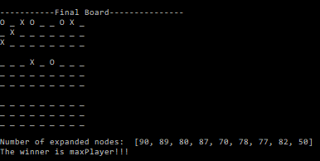

Game 2: Offensive(minimax) vs Defensive(alpha-beta) – maxPlayer first

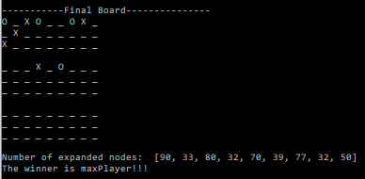

Game 3: Offensive(alpha-beta) vs Defensive(minimax) – minPlayer first

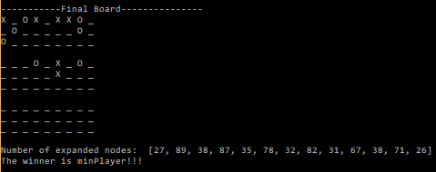

Game 4: Offensive(alpha-beta) vs Defensive(alpha-beta) – minPlayer first

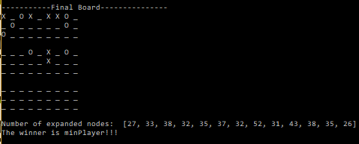

**Section III:** Ultimate Tic-Tac-Toe vs Designed Agent

Our new evaluation function assigned values to each of the local boards based on the number of empty spaces that would cause the next move to be in the current local board. For example, if the agent would must make its current move in the upper left-hand board (board 0), it would assign each potential move a higher score if it would force the predefined agent to make its next move in the current board. Basically, our designed agent knows that it has a higher chance of winning a local board if it can make more moves on the same board repeatedly. The remainder of the scoring heuristic was identical to the predefined agents.

Sample Game 1: Designed Agent start, Initial board 2

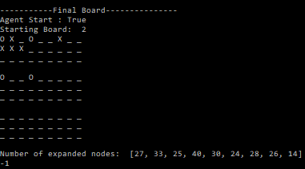

Sample Game 2: Designed Agent start, initial board 1

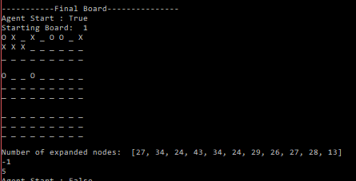

Sample Game 3: Predefined Agent Start, initial board 0

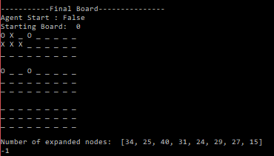

Sample Game 4: Predefined Agent Start, initial board 7

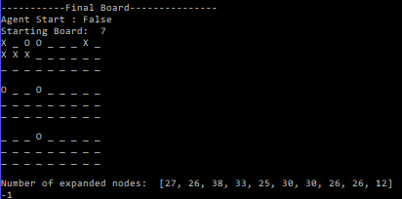

**Section IV:** Ultimate Tic-Tac-Toe vs Human

**Statement of Contribution:**